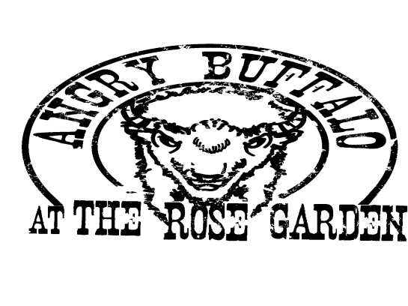
Angry Buffalo @ The Rose Garden
2753 Wehrle Drive
Williamsville, NY 14221
(716) 632-9871

Sales & Booking Events – Julie Jeziorski (716) 204-8152

2016 Catering Menu

Facility Fees
The following venues are available for rent for your next party, event or casual gathering:

The Stomping Grounds
A 10 acre grassy lot perfect for your next athletic event, swap meet, car show or teambuilding exercise.
Full Day (Up to 8 hours) - $250.00
½ Day (Up to 4 Hours) - $175.00

Covered Outdoor Bar & Tented Area
Perfect for benefits, reunions & large parties.
Full Day (Up to 8 hours) - $250.00
½ Day (Up to 4 Hours) - $175.00

The AB Lounge
Private room featuring private bar.
Great for birthday parties, stag/stagettes & happy hour events of 40 or Less
Full Day (Up to 8 hours) - $100.00
½ Day (Up to 4 Hours) - $75.00

Bar Packages
The following packages are available for you to choose from. Cash bar options available.

Bar Option 1 – Beer & Wine
Domestic Cans, Bottled House Wines (Red & White), Assorted Sodas and Juices

1 Hour $ 10.00 Per Person 4 Hour $ 16.00 Per Person
2 Hour $ 12.00 Per Person 5 Hour $ 17.00 Per Person
3 Hour $ 14.00 Per Person 6 Hour $ 18.00 Per Person

Bar Option 2 – Call Bar
The following Liquors, Draught Beer (Two Kinds - Domestic), Domestic Can Beers, Bottled House Wines (Red & White), Mixers, Assorted Sodas and Juices

Svedka Vodka, Jose Cuervo Tequila, Bacardi, Seagram’s VO Whiskey, Gordon’s Gin

1 Hour $ 14.00 Per Person 4 Hour $ 20.00 Per Person
2 Hour $ 16.00 Per Person 5 Hour $ 21.00 Per Person
3 Hour $ 18.00 Per Person 6 Hour $ 22.00 Per Person

Bar Option 3 – Top Shelf Bar
The following Liquors, Imported & Domestic Can Beers, Bottled House Wines (Red & White), Mixers, Assorted Sodas and Juices

Absolute Vodka, Bacardi Silver Rum, Herradura Tequila, Crown Royal Whiskey, Tanqueray Gin

1 Hour $ 18.00 Per Person 4 Hour $24.00 Per Person
2 Hour $ 20.00 Per Person 5 Hour $25.00 Per Person
3 Hour $ 22.00 Per Person 6 Hour $26.00 Per Person

½ Keg of Beer – Domestic $180.00/Keg

Labatt, Labatt Light, Pabst Blue Ribbon & Molson Golden,
Budweiser, Budweiser Light, Coors, Coors Light

½ Keg of Beer – Micro Brew or Imported Market Price

Appetizers/Hors d’oeuvres

Kettle Potato Chips $30.00 (Serves 25)
Kettle Potato Chips – (Loaded with Bacon & Cheese) $40.00 (Serves 25) Spinach & Artichoke Dip – with Nacho Chips $40.00 (Serves 25)
Hot Pretzel Sticks – with Honey Mustard and Warm Cheddar 30 pcs. @ $40.00
Bruschetta 50 pcs. @ $40.00
Spinach Bread 50 pcs. @ $40.00
Stuffed Mushrooms – Choice of:
Sausage & Parmesan or Spinach & Romano 40 pcs. @ $50.00
Stuffed Banana Peppers 30 pcs. @ $55.00
Italian Sausage – Peppers & Onions 50 pcs. @ $35.00
Chicken Wings – Hot, Medium, Mild or BBQ 50 pcs. @ $40.00
Chicken Fingers - Hot, Medium, Mild or BBQ 30 pcs. @ $50.00
Mini Chicken Sliders – Served with Coleslaw & Cheddar 30 pcs. @ $60.00
Mini Classic Burger Sliders – Served with Lettuce, Tomato 30 pcs. @ $60.00
Mini Pulled Pork Sliders – Served with Coleslaw & Cheddar 30 pcs. @ $50.00
Mini Beef on Weck – Served with Costanzo Rolls 30 pcs. @ $65.00
BBQ Bacon Wrapped Scallops Market Price
Shrimp Cocktail 30 pcs. @ $40.00
Sheet Pepperoni & Cheese Pizza (Approx. 30 Pieces) $30.00/Sheet
Each Extra Topping – Add $2.00

A La Carte - Each item/order serves approx. 25 people

Chef Salad – served with Balsamic & Ranch Dressings $35.00
Antipasto Salad $65.00
Baked Ziti $40.00
Pasta Salad – served with vinaigrette $40.00
Potato Salad or Macaroni Salad $35.00
Cheese, Pepperoni & Cracker Display $45.00
Vegetable Display – Served with Dip $40.00
Fruit Display $45.00

Buffets Options – Choice of Three
*Minimum – 20 Guests for buffet service

Buffet Option #1 - $12.95 Per Person ++ (under 5 yrs. old - free)

Chef Salad – served with choice of Ranch or Balsamic Dressings
Choice of - Potato Salad or Macaroni Salad
Italian Sausage – served with peppers and onions with rolls & condiments
Mini Pulled Pork – make your own sandwich served with coleslaw and cheddar cheese
Ice Cream Sundaes
Coffee & Tea

Buffet Option #2 - $13.95 Per Person ++ (under 5 yrs. old - free)

Chef Salad – served with choice of Ranch or Balsamic Dressings
Choice of - Potato Salad or Macaroni Salad
Mini Roast Beef Sandwiches – make your own served with Horseradish
Mini Chicken Sliders – make your own served with lettuce, tomato and cheddar with garlic aioli
Ice Cream Sundaes
Coffee & Tea

Buffet Option #3 - $15.95 Per Person ++ (under 5 yrs. old - free)

Chef Salad – served with choice of Ranch or Balsamic Dressings
Choice of - Mixed Seasonal Vegetables or Baked Ziti
Choice of – Potato - Roasted Baby Red Potatoes or Mashed w/Gravy
Herb Roasted ¼ Chicken
Sliced Roasted Beef in Au Jus – served with Rolls and Horseradish
Ice Cream Sundaes
Coffee & Tea

++ 18% gratuity and 8.75 % NYS Tax

Thank you for choosing Angry Buffalo @ The Rose Garden
We look forward to serving you!

